BCSE203E – Web Programming
Digital Assignment IV
Winter Semester 2025 – 2026
University Timetable Web Application
SyncIT

Student Details

Name: Aayush Kumar Singh
Registration No.: 24BKT0157
Name: Abhinash Kumar
Registration No.: 24BKT0159
Faculty: Jayakumar S
Semester: Winter Semester 2025-2026
Assignment Title: Mini Project
GitHub Links

GitHub Repository: https://github.com/aayushks22-05/Timetable-Generator

GitHub Pages: https://aayushks22-05.github.io/Timetable-Generator/
Table of Contents

S.No. | Section Title | Page No.
1 | Project Overview | 4
2 | Problem Statement | 4
3 | Features | 4
4 | Tech Stack | 5
5 | How the Application Works | 5
6 | Forms and Validation | 6
7 | Responsiveness and Usability | 6
8 | Role Distribution | 7
9 | Development Log | 7
10 | Conclusion | 7
11 | Screenshots | 8-11
1. Project Overview
This project is a University Timetable Web Application designed for students at VIT. It addresses a common frustration that many students face each semester. VTOP provides a dense course registration table that is hard to read quickly, particularly when figuring out what class is next or what you have the next morning. We created a tool that takes this raw data and transforms it into a clear, usable timetable that is easy to understand at a glance.
The app operates entirely in the browser with no server required. You paste your course registration data from VTOP, enter your name, choose your schedule pattern, and the app generates your personal timetable instantly. Besides showing a grid, it allows you to track your syllabus progress, add assignments with due dates, record your marks, and keep notes for each course.

2. Problem Statement
Students at VIT receive their timetable from VTOP in a format that is not very user-friendly. It doesn’t show what is happening today, remind you of upcoming deadlines, or help you track attendance or academic progress all in one place. Many students end up juggling multiple apps or trying to memorize their schedule.

We aimed to create a single, lightweight web app that students can open on their phone or laptop to access all the information about their schedule in one spot. No login, no server, and no complexity.

3. Features
The application features a setup screen where students can enter their name and paste their VTOP course registration data. The app then parses the information and lays it out according to the correct days and times.

Once created, the timetable displays a complete weekly grid view. Users can switch to a Day View that shows either today's classes or those for another selected day in a simple card format.

Each course cell in the timetable is clickable, which opens a Course Hub modal. This modal contains four tabs. The Overview tab displays the faculty name, venue, assigned slots, and school. The Syllabus tab lets you add topics and mark them as covered. The Assignments tab allows you to enter assignment titles with due dates. The Performance tab is where you record your CAT 1, CAT 2, Internal, and FAT marks, and the app automatically calculates your total out of 100.

There is a global Assignments view accessible from the main screen that lists all upcoming tasks across all courses for the next 14 days.

The app supports both light and dark themes. It remembers your preference using local storage. It also features a live clock and a current status indicator so you can see what’s happening right now in your schedule.

4. Tech Stack
The entire application is built with basic HTML, CSS, and JavaScript. No frameworks or external libraries are used, which keeps the app fast and easy to host anywhere.

HTML takes care of the structure, including the input form, timetable, day view, modal dialog, and tabs. CSS handles the visual design, including a complete dark and light theme system built with CSS custom properties. JavaScript manages all the logic, including parsing the VTOP data, building the timetable grid, managing state, and handling interactions in the course hub. Local storage saves timetable data and course information between sessions so users do not have to re-enter everything each time they open the app.

5. How the Application Works
When users paste their VTOP course registration data, the JavaScript parser reads through each row to find slot codes, course names, faculty names, venue names, and school names. It maps each slot code to the appropriate day and period using predefined slot grids for morning theory, evening theory, and mixed schedules.

The timetable grid is built dynamically using JavaScript to create the table header and body elements. Each cell displays the course name and a color from a predefined palette. Courses sharing the same code receive the same color, making them easy to identify throughout the week.

All course metadata, such as syllabus topics, assignments, and marks, is stored in local storage under the student's timetable key. This data remains available even after page reloads.

6. Forms and Validation
The assignment necessitates at least three forms with proper validation. Here’s how we fulfill that requirement.

The first form is the Timetable Setup form on the landing page. It includes a Student Name field that is required, along with a Course Registration Data textarea, which is also mandatory. If either is left blank and the user tries to generate the timetable, the browser displays a validation message.

The second form is the Syllabus form inside the Course Hub modal. When a user tries to add a topic to the syllabus list, the input is checked to ensure it isn’t empty before the topic is added.

The third form is the Assignments form inside the Course Hub modal. When a user adds an assignment, the title field is required. The date field is optional but, if filled, it is checked to ensure it follows a proper date format.

The fourth form is the Performance or Marks form inside the Course Hub modal. Each mark field validates that the entered value does not exceed the maximum allowed. For example, CAT 1 and CAT 2 are out of 50 each, Internal is out of 30, and FAT is out of 100. If an out-of-range value is entered, the input is highlighted, and an error message appears.

7. Responsiveness and Usability
The app is designed to function on both desktop and mobile screens. On larger screens, the full weekly grid is visible. On smaller screens, the table becomes horizontally scrollable so nothing gets cut off. The Day View mode is particularly helpful on mobile since it presents a single day's classes as cards rather than a wide table.

The dark mode toggle is positioned at the top right corner and works on all screen sizes. The modal dialogs are also responsive and scroll internally on smaller screens to ensure all content remains accessible.

8. Role Distribution
As a two-member team, both of us participated in all aspects of the project without strict boundaries between roles. However, here is a rough division of responsibilities.
9. Development Log
- We finalized the project idea and chose to build a VTOP timetable parser since it was something we personally needed.

- We set up the GitHub repository and created the initial project structure with separate HTML, CSS, and JS files.

- We built the basic landing form with student name input, course data textarea, and session pattern selection.

- We implemented the VTOP data parsing logic to extract course names, slot codes, faculty, venue, and school from the raw pasted text.

- We created the slot-to-day mapping for morning theory, evening theory, and mixed schedule patterns.

- We built the timetable grid renderer to dynamically create the table according to parsed course data.

- We added a color palette system so each course has a consistent color throughout the timetable.

- We designed the full CSS theme system with dark and light modes, utilizing CSS custom properties and a toggle button.

- We built the Course Hub modal with four tabs: Overview, Syllabus, Assignments, and Performance.

- We implemented syllabus topic tracking with checkboxes and assignment tracking with due dates.

- We created the marks section with automatic total calculation and out-of-range validation.

- We added local storage so all course data, marks, and assignments are saved between sessions.

- We built the Day View with day-selector buttons that display a single day’s classes as cards.

- We developed the global Assignments view that lists all tasks due in the next 14 days across all courses.

- Finally, we added a live clock and current class status indicator to the main timetable header.

- We tested it on the browser and then pushed the final version to GitHub.

10. Conclusion
This project gave us a great chance to build something we would actually use ourselves. Working with raw VTOP data and creating a functional, user-friendly interface taught us a lot about DOM manipulation, state management, and CSS theming without using any external frameworks.

The application meets all the technical requirements of the assignment, including multiple validated forms, responsiveness, and a clean UI. We plan to keep improving it based on feedback from other students.

11. Screenshots
The following screenshots show the application in use.
Screenshot 1 – Timetable Setup Screen

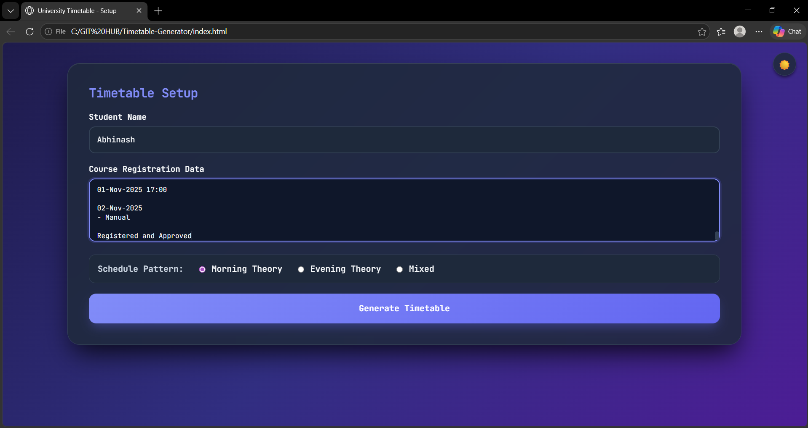
Screenshot 2 – Weekly Timetable View (Table View)

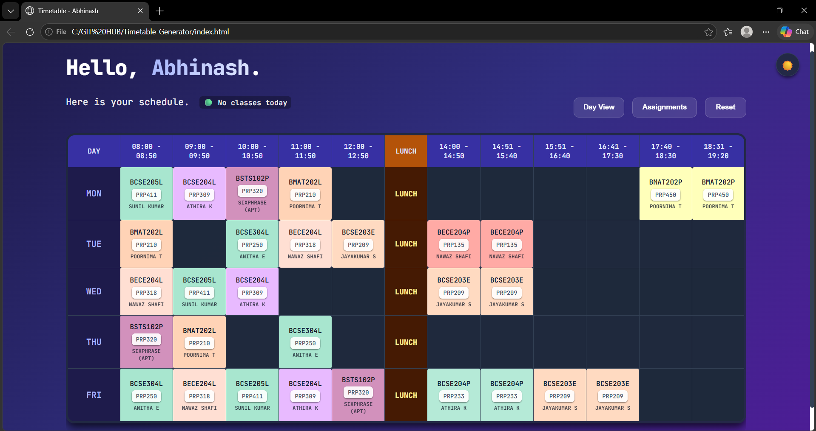

Screenshot 3 – Weekly Timetable View (Day view)

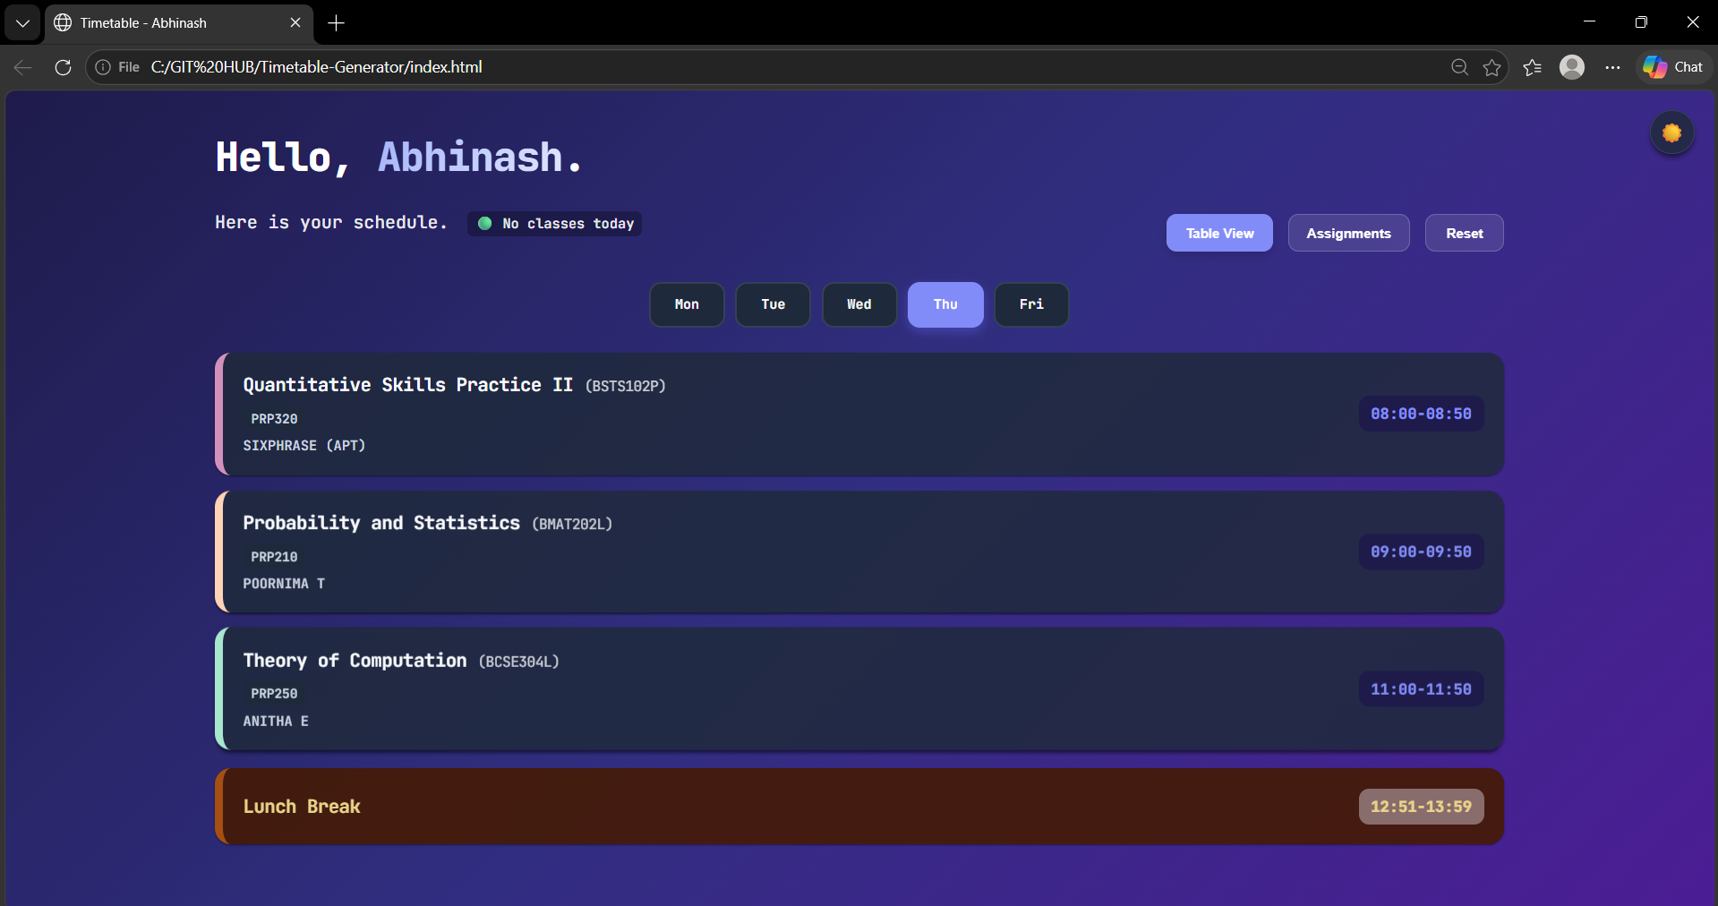
Screenshot 4 – Course Hub Modal

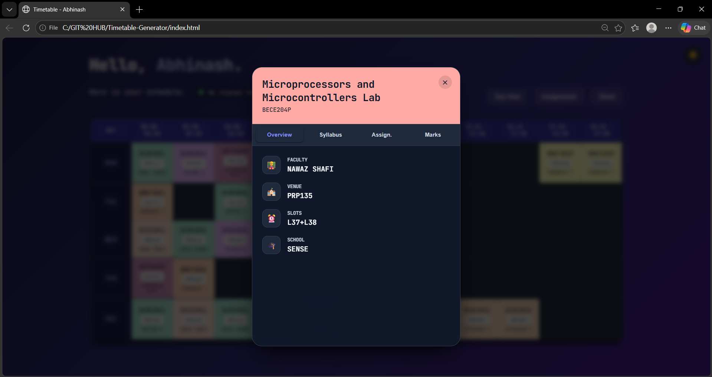

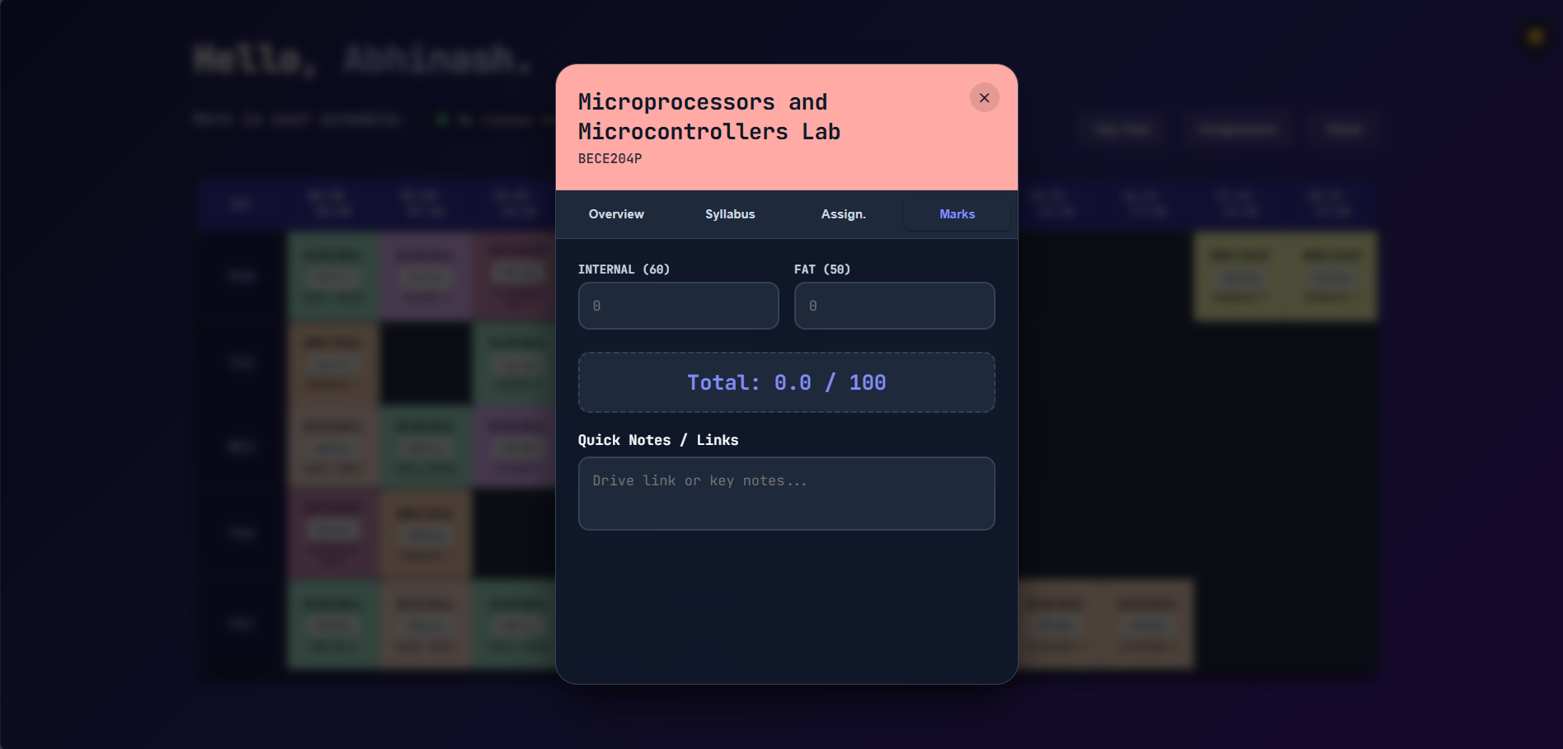
Screenshot 5 – Assignment Section

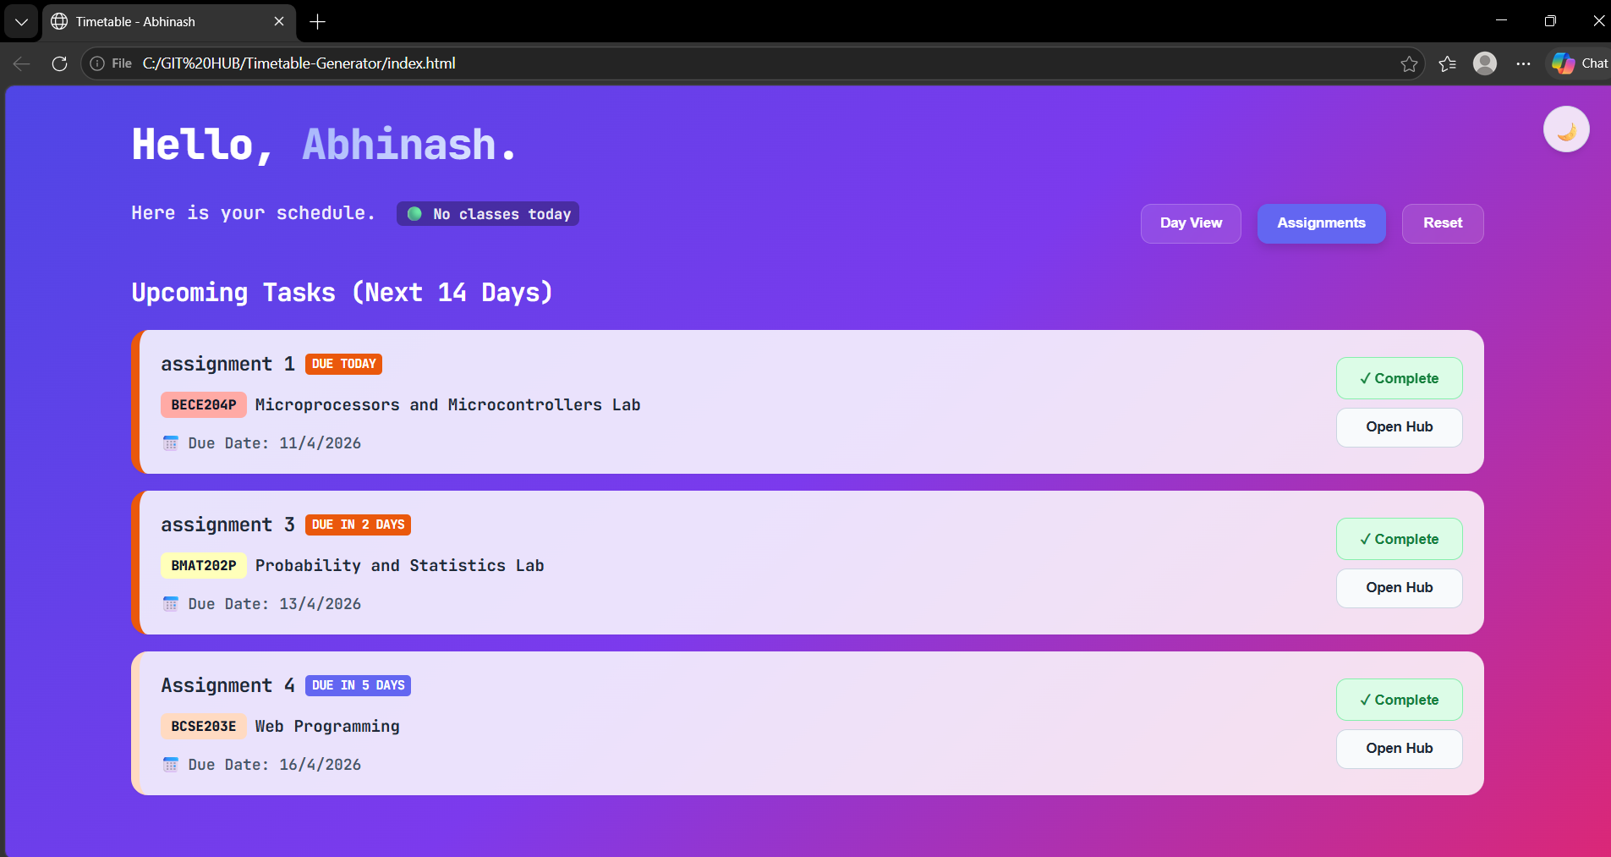

Screenshot 6 – Day View

